EXPERIMENT 4 – String Handling Using Raptor
AIM
To design a flowchart using Raptor to display and return the total number of characters present in a given string.
PROCEDURE
- Open Raptor and create a new flowchart.
- Use an Input Symbol to accept a string from the user.
- Store the entered string in a variable named str.
- Use an Assignment Symbol to find the length of the string.
- Calculate the character count using:
count ← Length(str)
- Use an Output Symbol to display the total number of characters.
- Execute the flowchart.
- Enter different string values to test the flowchart.
- Verify that the displayed count matches the number of characters in the entered string.
- Validate the flowchart and confirm that the output is correct.
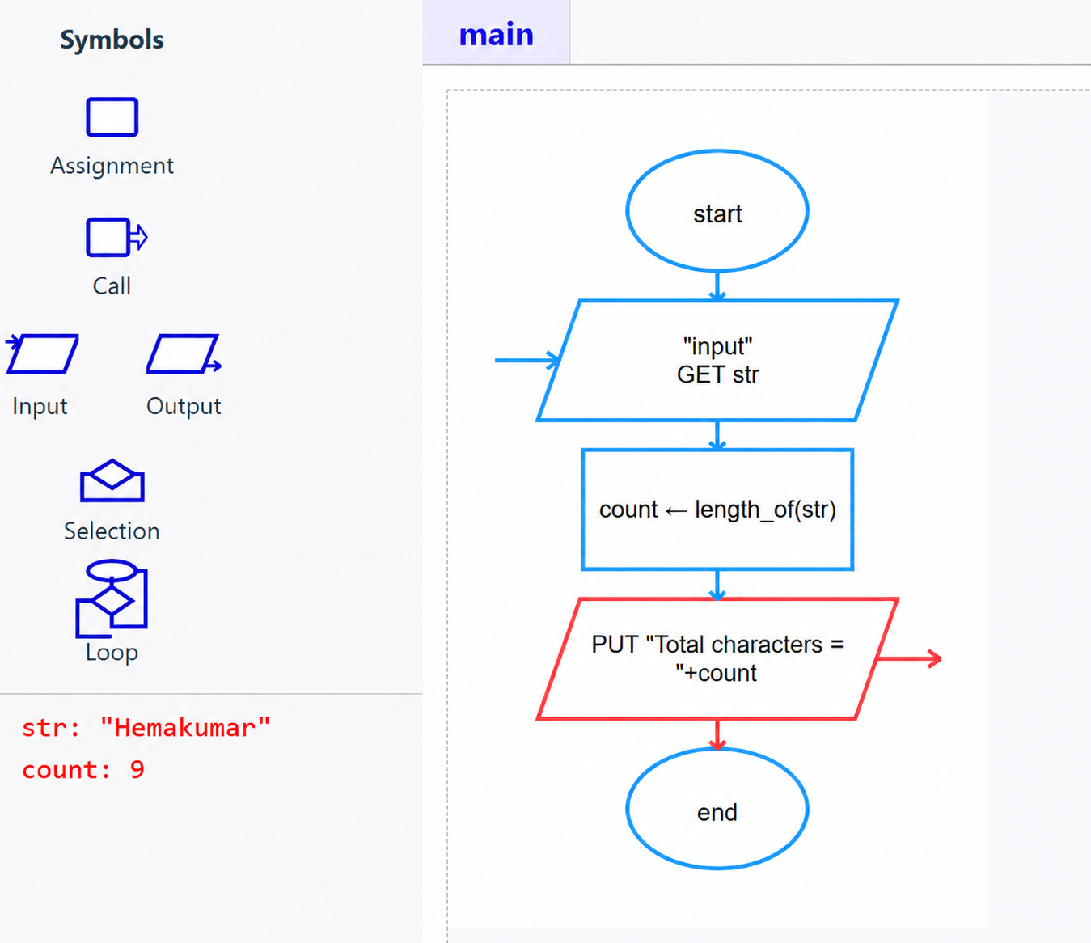
OUTPUT:
RESULT
RESULT:
Thus, the flowchart for displaying and returning the total number of characters in a string was created and validated successfully using Raptor.

